- The rise in UK CPI inflation in July was fractionally higher than our forecast and consensus expectations. The upside surprise was due to the volatile air fares and accommodation services categories, and this should prove temporary. As a result, our forecast is little changed, and we expect inflation to average 3.5% this year and 2.8% in 2026.
- Headline inflation is likely to climb to 4% over the next couple of months, peaking in September. Thereafter, we expect inflation to drift lower, with the contribution from the energy and food categories likely to fall in the final months of this year and through 2026. Though services inflation will remain sticky in the near-term, it should start to cool steadily next year.
CPI inflation increased to 3.8% in July, from 3.6% in June, an outturn that was fractionally higher than our forecast and consensus expectations. July's upside surprise was largely due to the volatile accommodation services and air fares components, with the Office for National Statistics suggesting the latter was linked to a later price collection date which coincided with the timing of school summer holidays. Together, these categories added 0.2ppts to the headline rate. Elsewhere, there was also a smaller drag from the fuel category, following a 1.7% increase in petrol prices between July and June, compared to a 0.9% decline over the same period last year. RPI and RPIX inflation rose by 0.4ppts to 4.8% and 4.7% respectively.
The upward pressures from air fares and accommodation services should quickly unwind, but base effects mean that headline inflation is likely to edge up a little further over the next couple of months. Thereafter, we expect inflation to start to drift downwards. The positive contribution from the energy category should disappear entirely from October. Food price inflation is expected to cool gradually over the final months of this year and into 2026, as the impact of stronger sterling slowly feeds through. Meanwhile, services inflation is likely to remain sticky in the near-term, before starting to cool steadily next year.
Given today's data came in broadly as expected, and there has been little movement in the underlying drivers, our inflation forecast is little changed compared with last month. We expect CPI inflation to average 3.5% this year and 2.8% in 2026.
Chart 1: We expect inflation to cool in the final months of this year and through 2026
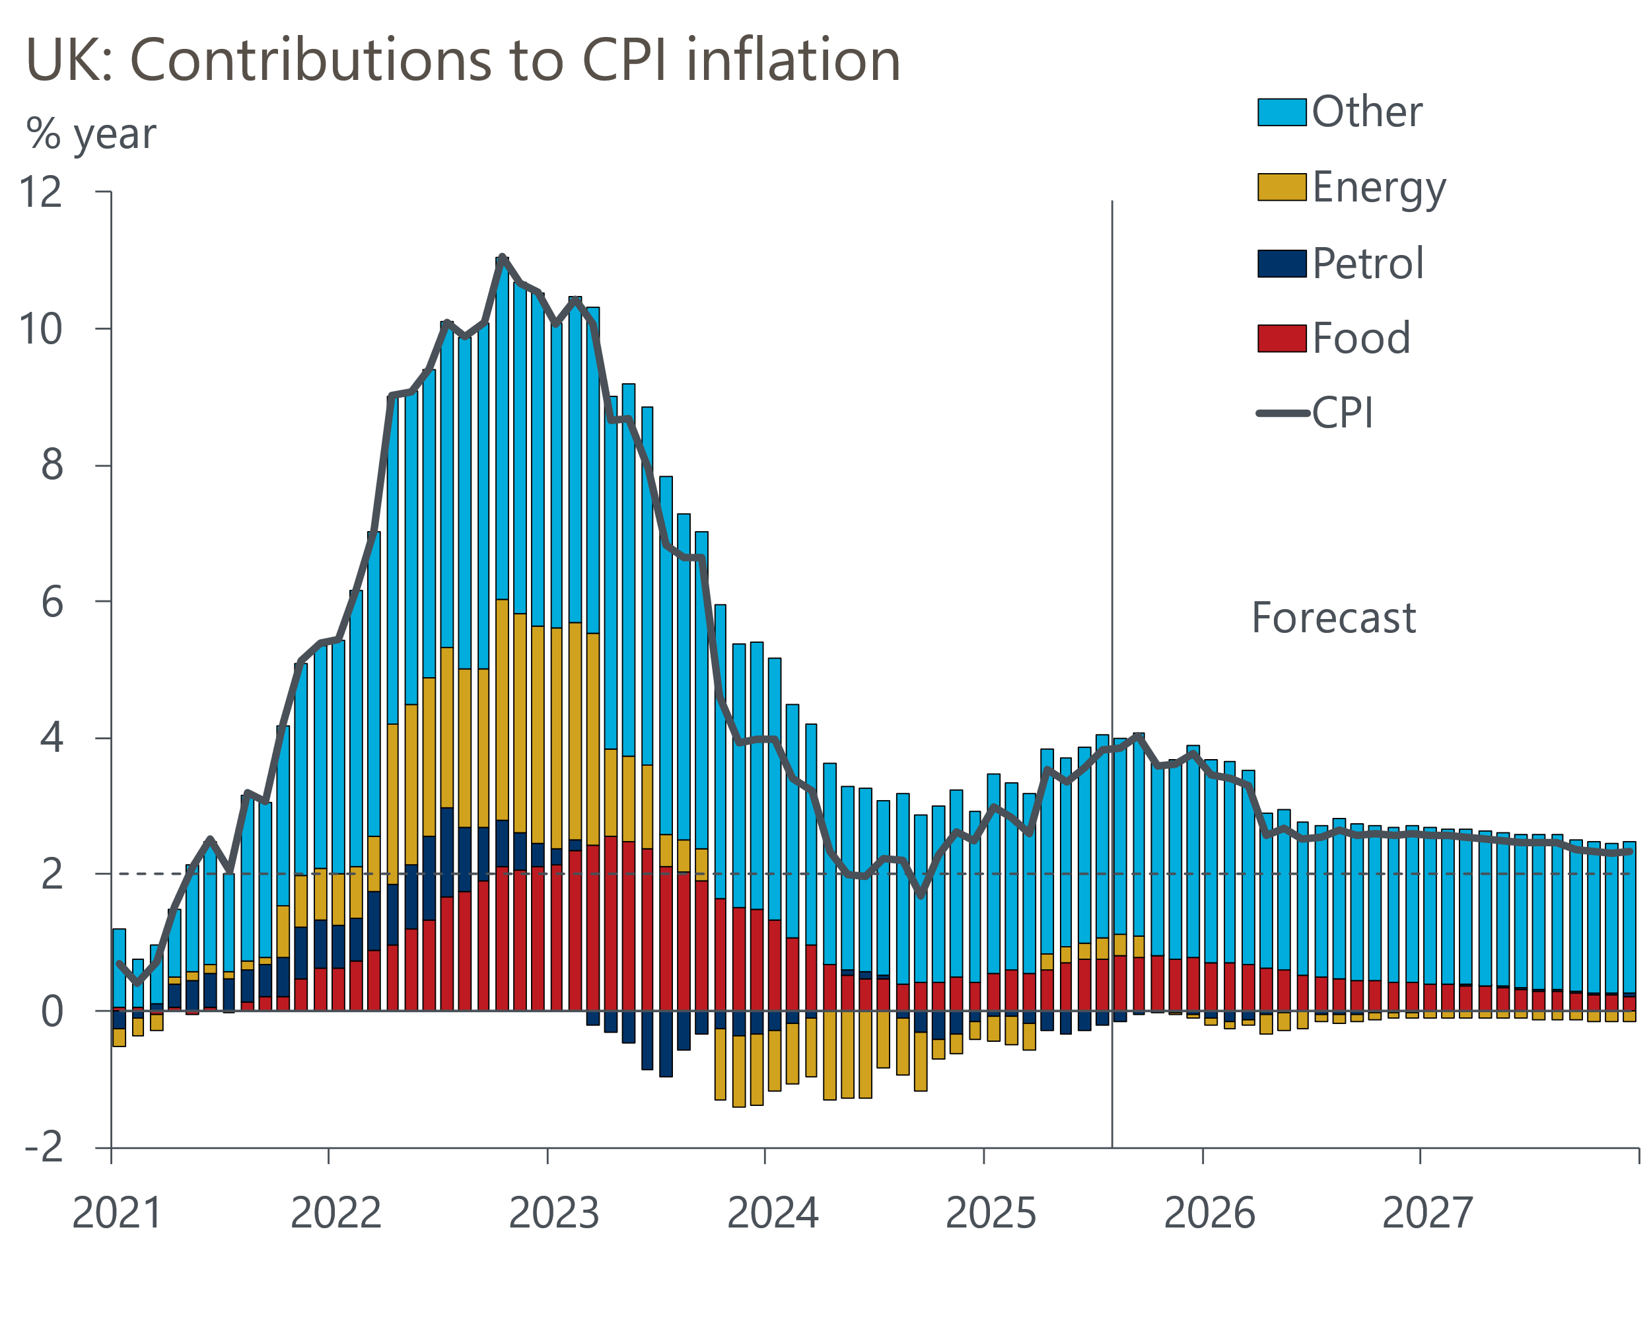
Source: Oxford Economics, Haver Analytics

